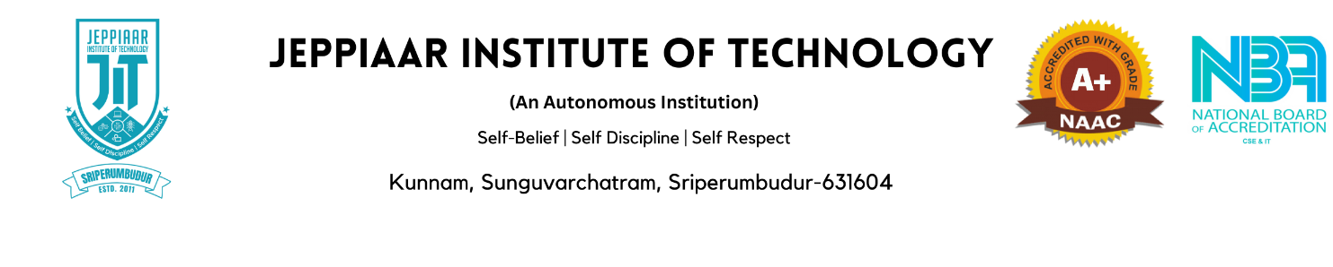

**BOARD OF STUDIES MEMBERS**

**DEPARTMENT OF MECHANICAL ENGINEERING**

|  |  |  |  |
| --- | --- | --- | --- |
| **S.No** | **Name** | **Designation** | **Role** |
| 1 | Mr.S.Arun | Assistant Professor,  Department of Mechanical Engineering,  Jeppiaar Institute of Technology. | Chairperson |
| 2 | Dr.N.Sendhil Kumar | Associate Professor,  Department of Mechanical Engineering, National Institute of Technology,  Karaikal, Puducherry – 609 609 | University Representative |
| 3 | Dr.Simon Jeyaraj | Professor,  Department of Mechanical Engineering,  National Institute of Technology, Calicut. | Subject Expert |
| 4 | Dr.P.Vamsi Krishna | Professor,  Department of Mechanical Engineering,  National Institute of Technology, Warangal. | Subject Expert |
| 5 | Mr.N.Lakshminarasimhan | Senior General Manager (P&HR)  Brakes India Private Limited, Padi, Chennai. | Industry expert |
| 6 | Mr.M I Abdhul Halik | Operations Lead Forte Consulting,  Chennai. | Alumni Member |
| 7 | Mr.D.Ajithkumar | Assistant Professor,  Department of Mechanical Engineering,  Jeppiaar Institute of Technology. | Member |
| 8 | Mr.J.Sudhakar | Assistant Professor,  Department of Mechanical Engineering,  Jeppiaar Institute of Technology. | Member |
| 9 | Mr.M.Kubendiran | Assistant Professor,  Department of Mechanical Engineering,  Jeppiaar Institute of Technology. | Member |
| 10 | Mr.M.Sugadevaboopathi | Assistant Professor,  Department of Mechanical Engineering,  Jeppiaar Institute of Technology. | Member |
| 11 | Mr.S.Jasper | Assistant Professor,  Department of Mechanical Engineering,  Jeppiaar Institute of Technology. | Member |